

**Children Quality of Life Study**

**Information Sheet for children KS1**

***You may want to ask the people you live with to read this with you***

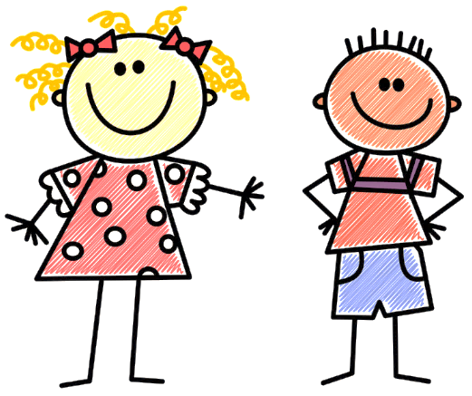

**We want to know what is important to you in your life**

**We want to know about what makes you happy….**

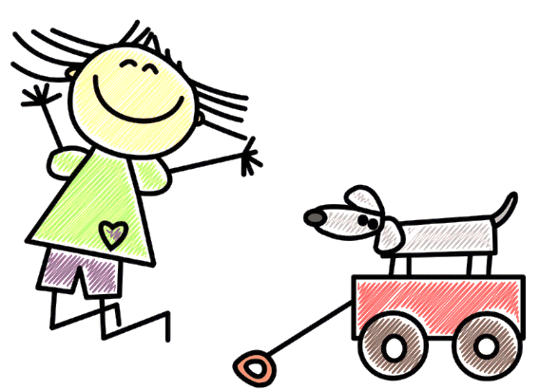

**And the things you like to do….**

**If you agree, Sam would like to talk to you on the computer about what is important to you**



**Sam will write things down and record what you say, but everything you say will be private**

**You might be asked to draw some of the things important to you!**

**We might have to share what you tell us if we are worried about you**

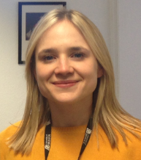 **If you want Sam to come and talk to you, that’s great!**

**But you don’t have to do it. You can say no at any time and you don’t have to say why.**

**Hi, my name is Sam and I am a researcher! I would like to come and talk to you ☺.**